Course-End Project-2:
Project Agenda: To create high available architecture by distributing incoming traffic among healthy service instances in cloud services for virtual machines in a Load-Balancer
Description:
The Rand Enterprises Corporation wants to deploy a web application in a highly available environment so that only the healthy instances will be serving the traffic to end users will not be facing any downtime. They have decided to work on an Azure public load balancer to implement the functionality.
The Devops team at Rand decides to define the entire architecture using the load balancer and its backend pool, once that’s in place they intend to create the frontend IP and health probe along with virtual machines housing their application.
Rand Enterprises works extensively on delivering highly available web applications for their users in a secure way by avoiding directly exposing the virtual machines hosting the applications to the public internet. The communication from the application in the VM to the end-user must take place via the Load Balancer.

As a security measure, you need to ensure that only the healthy instances of the virtual machine will be serving the traffic.

Now as part of testing will ensure that the load balancer should balance the network traffic between the servers for the incoming traffic.…when it is been requested by different users it should redirect the users to different servers which are part of Load balancer

Also you need to ensure that the onboarded Operations team members can only access the resources mentioned in the custom role and adhere to the principle of least privilege.

Technical briefing of the Project:

In this project will provision high availability infrastructure with web application inside it which is always browsable to the end users in case of an outrage of any one workload under Azure Load Balancer.

Architectural diagram of Project workflow:

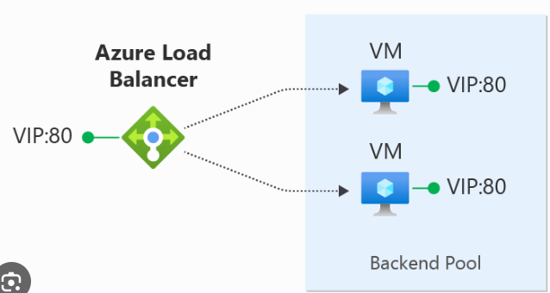

Tools required: Azure account with administrator access.

Prerequisites: None

Expected Deliverables:
      - Create a Resource Group
      - Deploy 2 VM’s in same region, same network, same RG, should in AS
      - Install IIS in both the VM’s
      - Design the html page in both the VMs
      - Detached the VMs with Public IP addresses.
      - Deploy a Load Balancer
      - Add the 2 VMs inside the Load Balancer.
      - Setup the Health Probe for VM’s Health Check
      - Implement the inbound & outbound rules inside the LB
      - Verify the Load Balancer IP & VM’s Ips should be common
      - Perform the testing.
      - Create a group in Azure to add multiple operations team members
      - Provider contributor access to the Group of operations team members which helps them to manage/maintain the high available infrastructure

